Nicholas McClellan

October 11th, 2019

EENG310

Matlab Assignment #3

**Assignment Part 1:**

A. The line i = n + N + 1 is responsible for determining the index of the coefficient being solved for. Further, the +1 increment is to adjust the indexing to match Matlab syntax, such that we begin indexing at 1 rather than 0. We cannot index using n because it stores negative values, and indices cannot be non-positive integers.

B.

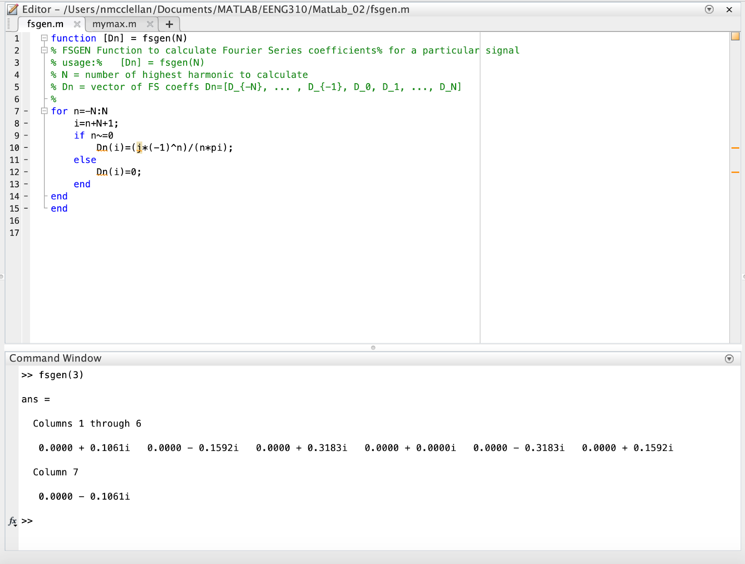

C.

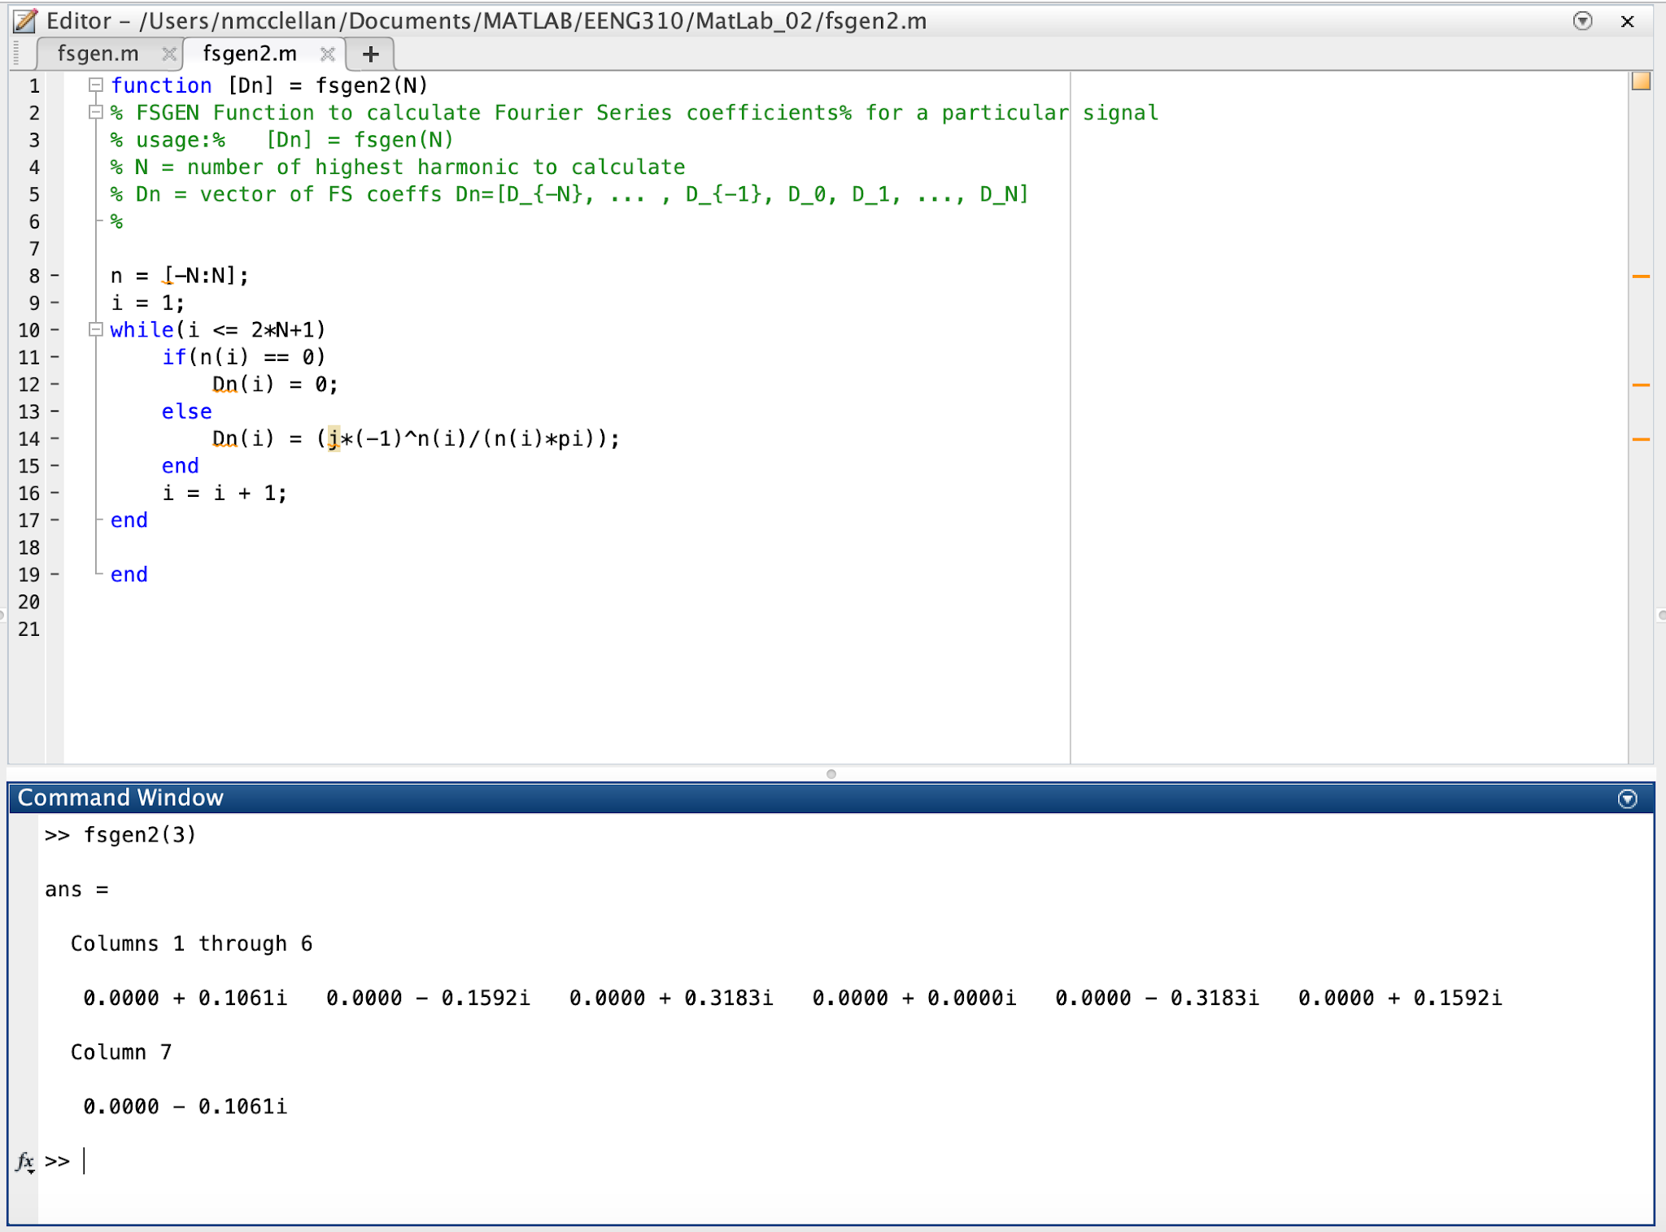

D.

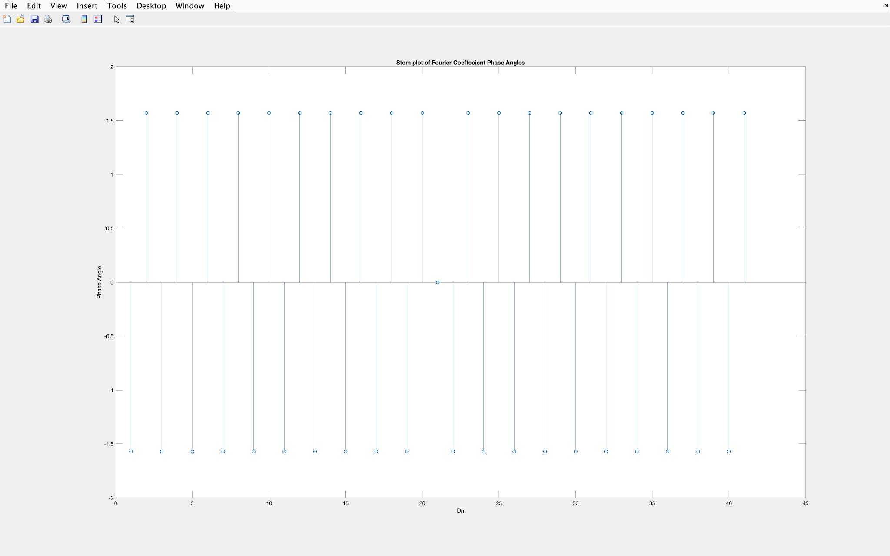

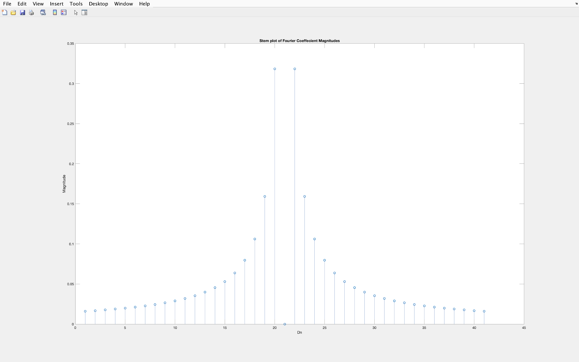

**Assignment Part 2:**

A.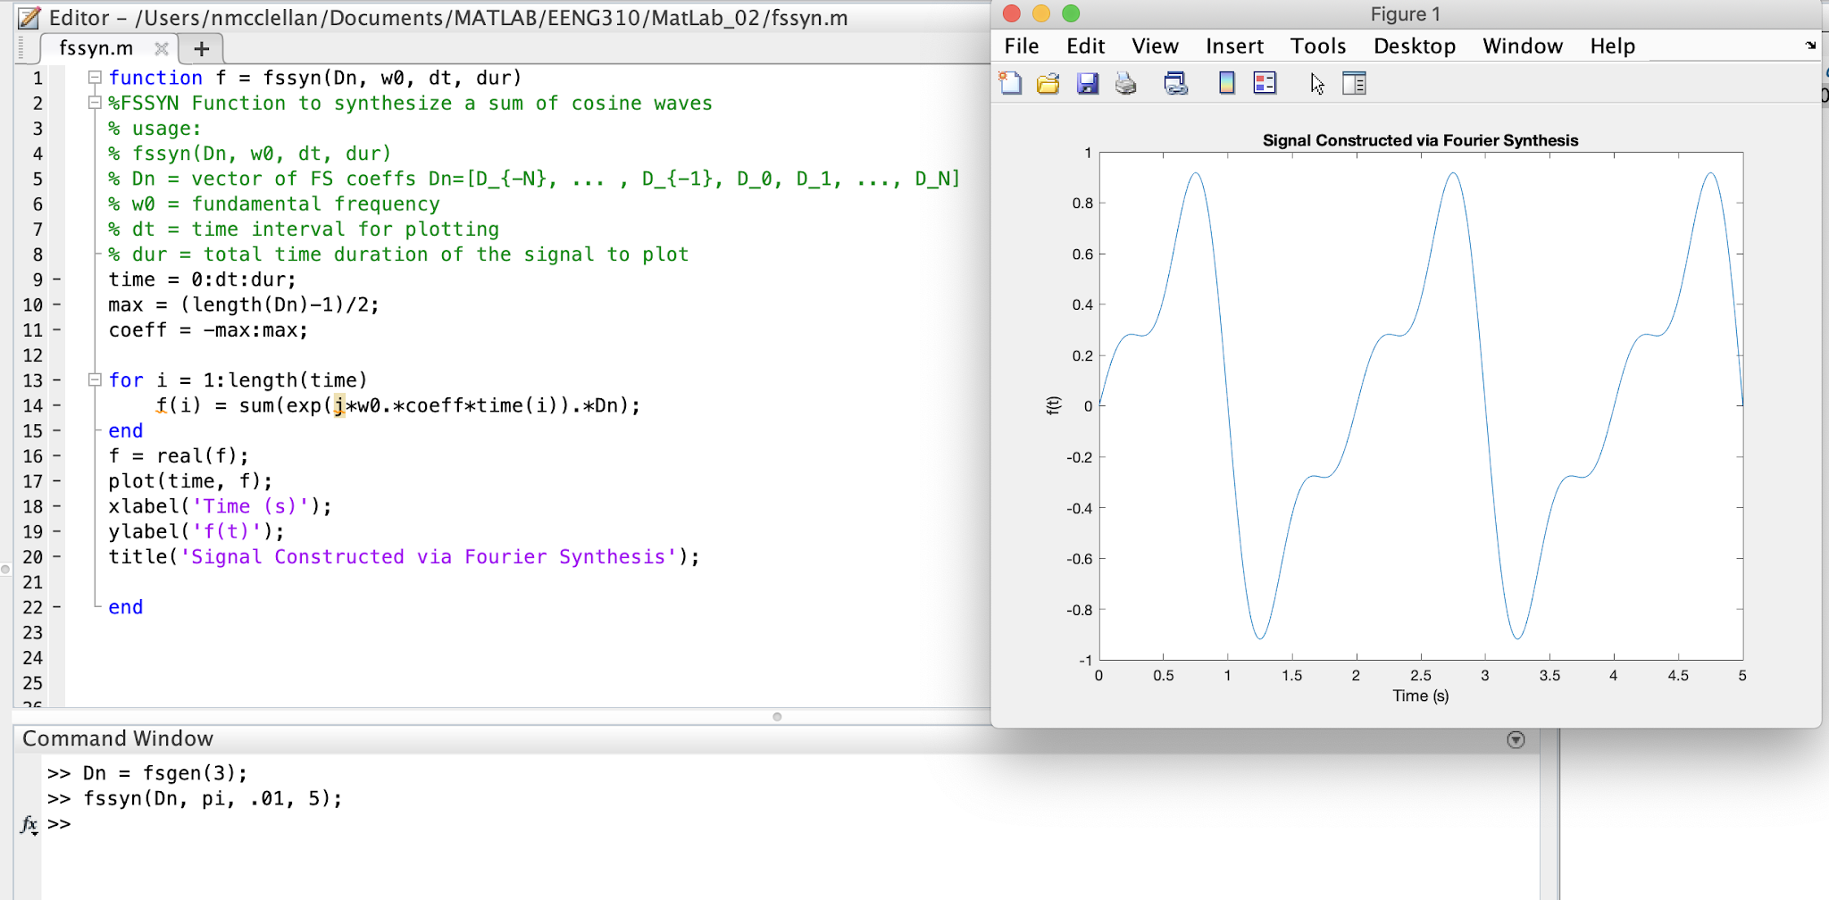

B.

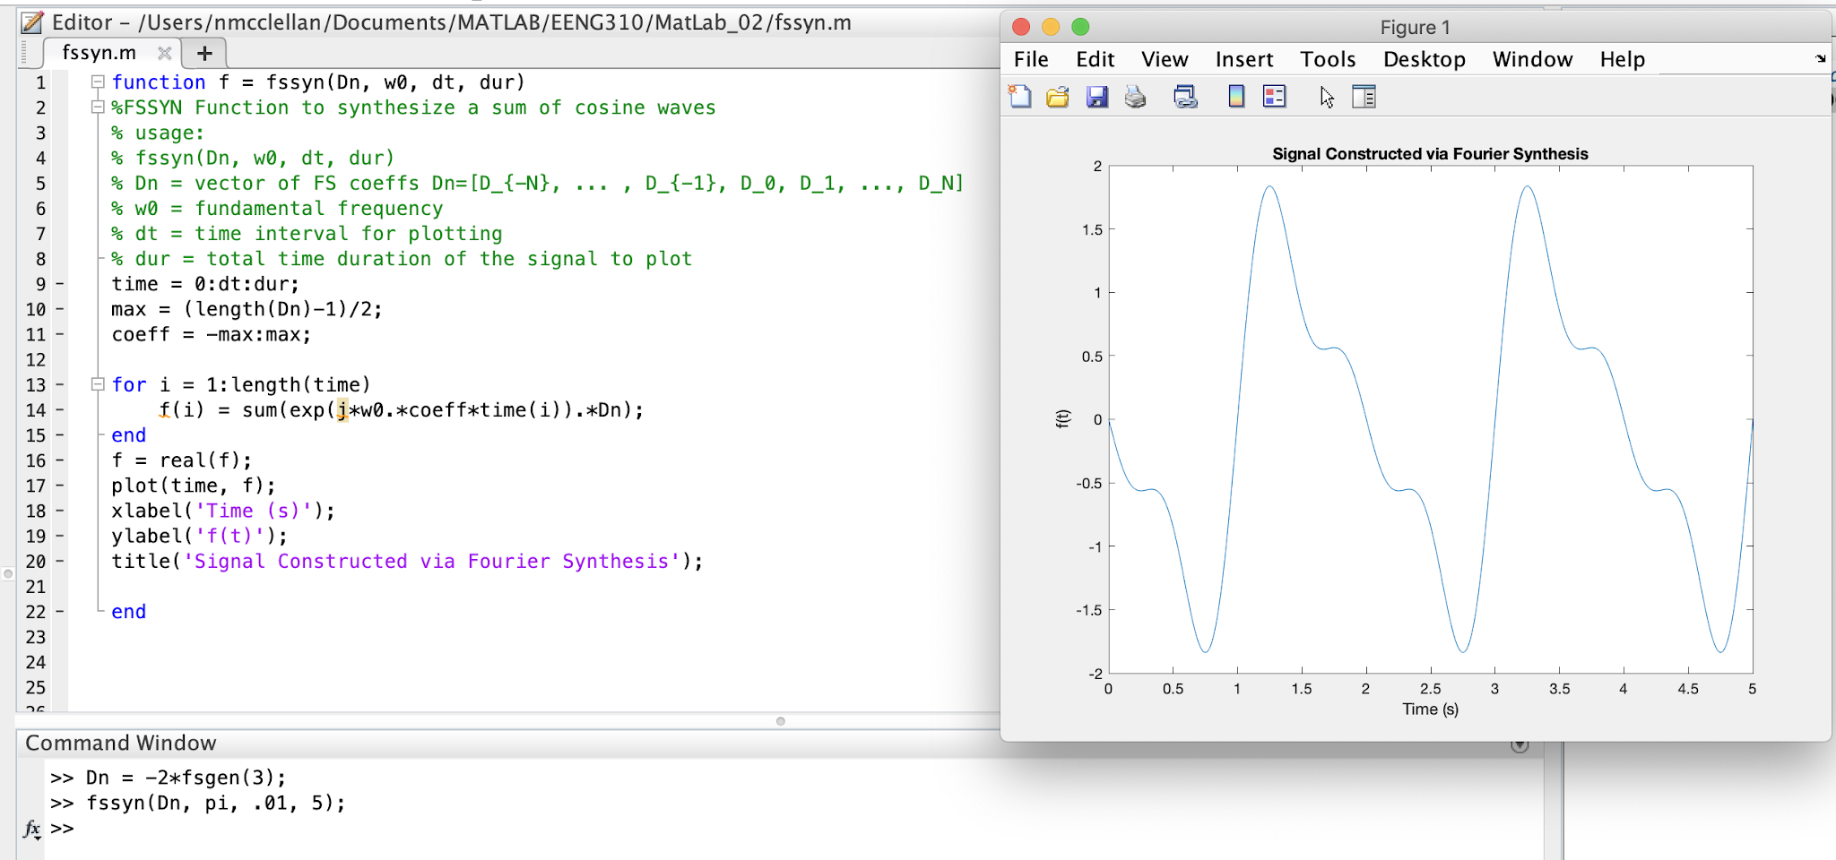

The difference in this plot compared to part a is the presence of a constant multiple. Further, the (-2) multiplier doubles the functions amplitude, as well as reflects it across the y-axis.

C.

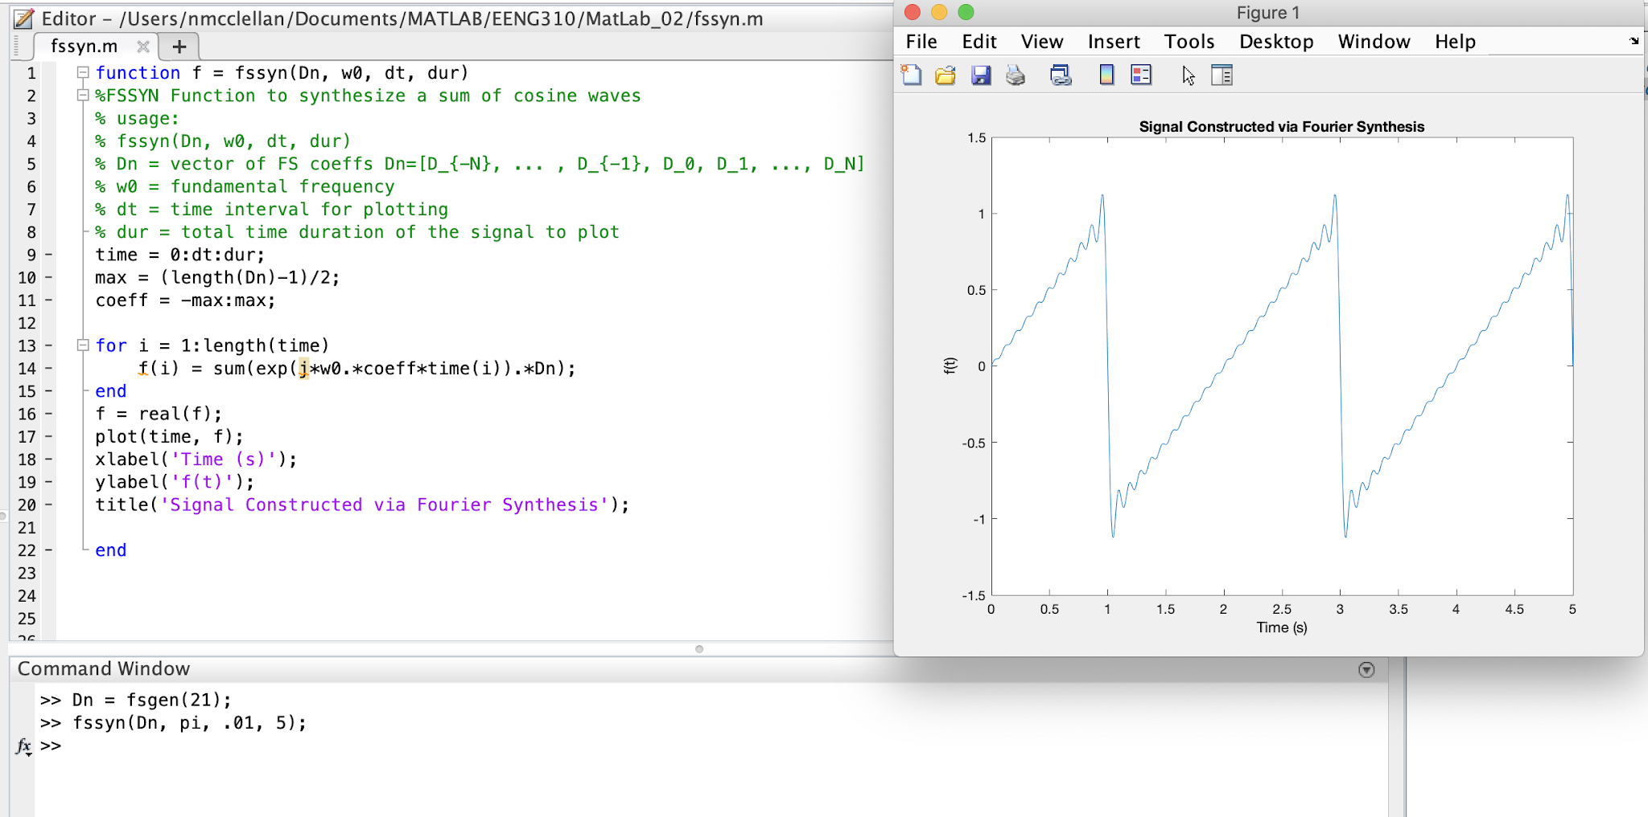

The difference in this plot compared to part a is the additional fourier series coefficients being found. Further, the parameter (21) in the “fsgen” function provides the generate equation with many more data points. The effect can be seen in the more distinct shape of the graph, as well as the sharper edges.

D.

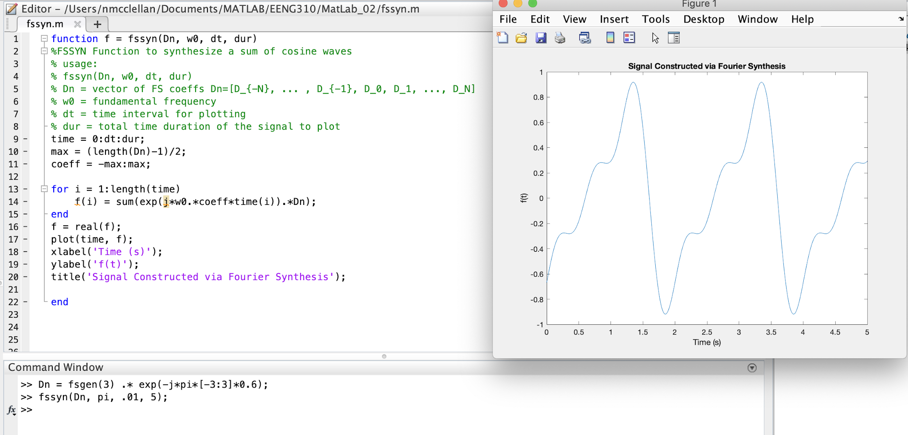

The difference in this plot compared to part a is the shift of the waveform to the right by approximately. Further, the multiplication of the generate function by that complex exponential tells us that there is a time shift. The effect can be seen in the shift of the waveform from part a.

E.

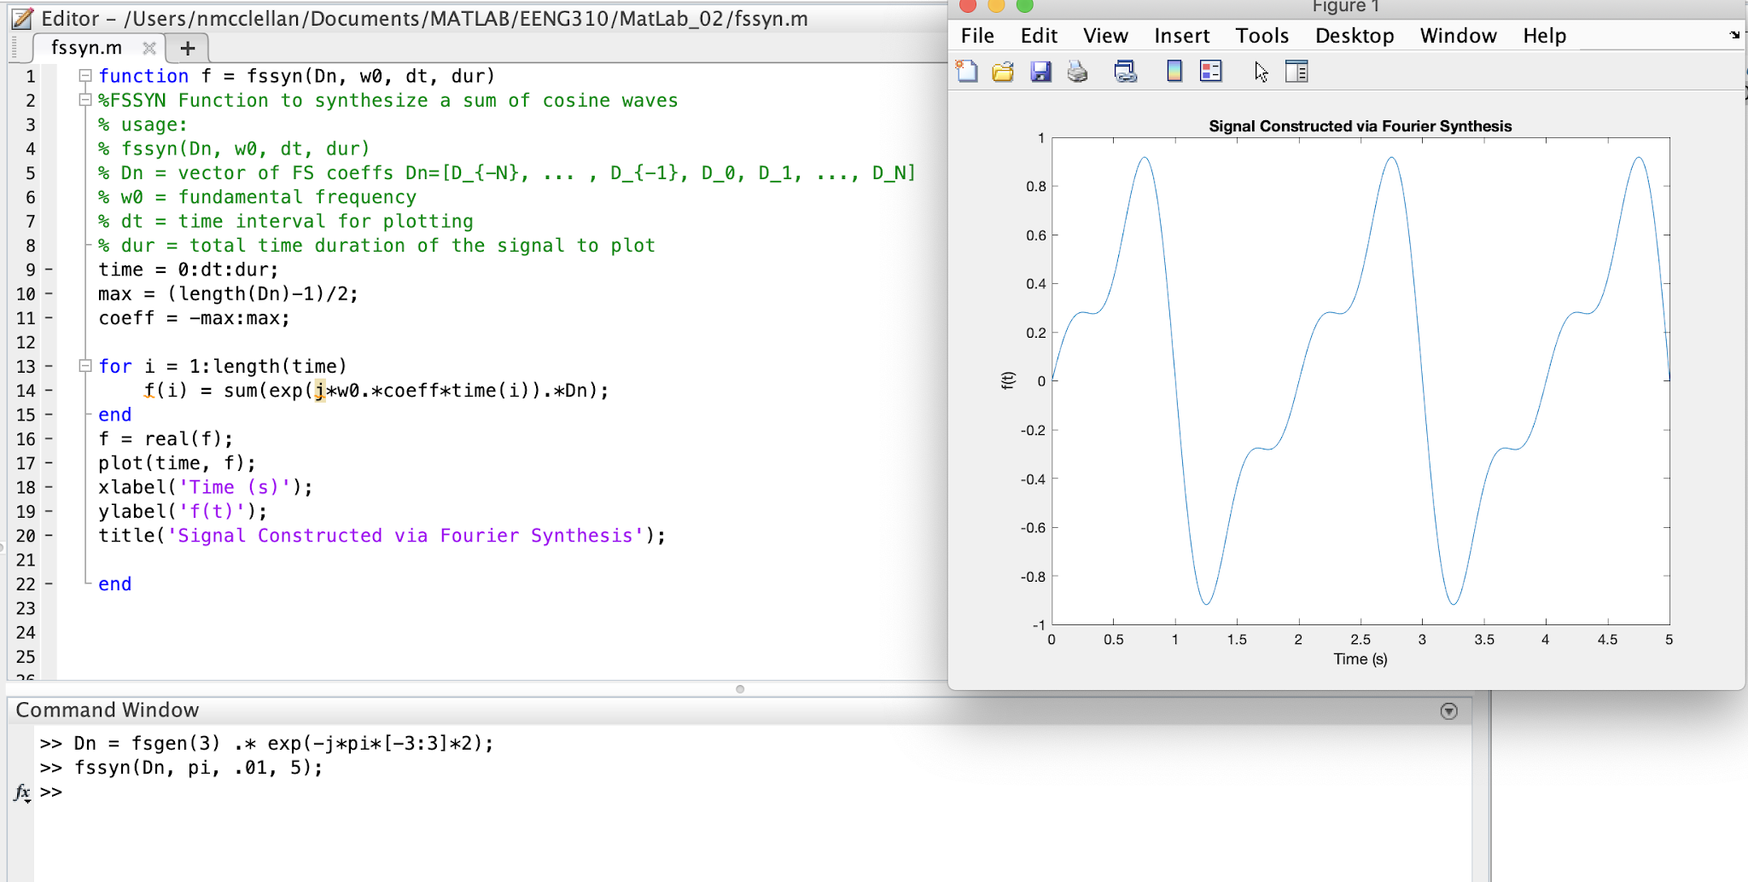

Similarly, the difference in this plot compared to part a is the shift of the waveform to the right by approximately. Further, the multiplication of the generate function by that complex exponential tells us that there is a time shift. The effect can be seen in the shift of the waveform from part a. To summarize the previous two parts, the -j indicates the shift is towards the right, and the coefficient on indicates the amount of shift.